TREE PERMIT APPLICATION
CITY OF RACINE, WISCONSIN ♦ FORESTRY DIVISION ♦ (262) 636-9131 ♦ prcs@cityofracine.org

Complete this application and submit via email to prcs@cityofracine.org, in person or mail to: Parks, Recreation & Cultural Services Department, 800 Center Street, Room 127, Racine, WI 53403. An online application is also available in lieu of a paper copy.

Reference the Tree Permit Policies on page 3 for information about permit types and associated requirements.

Applicant Name/Company: _________________________________________________ Date of Application: ____________________
Residential or Business Address (Street, Zip Code): ____________________________________________________________________
Email: __________________________________________________________ Phone #: ____________________________________
Work Location Address: _________________________________________________________________________________________
By signing this document, I am indicating that I am familiar with the provisions outlined in the Tree Permit Policies that begin on page 3. I understand all approved work shall conform to standards and specifications set forth within these documents. Fees or penalties may be assessed for tree damage or work performed in excess of what is approved by a permit.

Applicant Signature: __________________________________________ ISA Certification #: ____________________________

(Required for Pruning and Plant Health Care only)

TYPE OF PERMIT REQUESTED:

- Standard Tree Permit – intended for one-time work

- Annual Tree Permit – intended for work that will occur throughout the year

FOR STANDARD PERMITS:
Check all boxes pertaining to the desired type(s) of work to be completed.
- Tree Planting

- Tree Pruning

- Tree Removal

- Plant Health Care

- Root Pruning Required for Sidewalk Repair

- Other, Specify: __________________________________________________

Standard Permit Questions:

- For tree planting only, what species do you want to plant? What caliper (trunk diameter at 6-inches above ground level) is the tree(s)? List them below.

Tree 1: ______________ ____-inches Tree 2: ______________ ____-inches Tree 3: ______________ ____-inches
(species) (caliper) (species) (caliper) (species) (caliper)

- For Pruning, Tree Removal, and Plant Health Care, why does this work need to be completed?
Answer: ____________________________________________________________________________________________

- List the species and trunk diameter (measured at chest height) for each tree:
Tree 1: ______________ ____-inches Tree 2: ______________ ____-inches Tree 3: ______________ ____-inches
(species) (diameter) (species) (diameter) (species) (diameter)

- List the estimated work start and end dates: Start: ___________________ End: ___________________
FOR ANNUAL PERMITS:
Check all boxes pertaining to the desired type(s) of work to be completed.
- Sewer Lateral Repair/Installation

- Water Line Repair/Installation

- Gas Line Repair/Installation

- Sidewalk Repair

- Utility Vegetation Management

- Plant Health Care

- Trenching and/or Excavating

- Directional Boring

- Root Pruning

- Other, Specify: ______________________________________________

DO NOT WRITE BELOW THIS LINE – FOR OFFICE USE ONLY

Date Received: ___________________________ Received By (Staff Initials): ___________________________
- Permit is Approved
- Permit is Approved with Modification
- Permit is Denied

Comments: __________________________________________________________________________________________________
____________________________________________________________________________________________________________
____________________________________________________________________________________________________________
____________________________________________________________________________________________________________
____________________________________________________________________________________________________________
____________________________________________________________________________________________________________
____________________________________________________________________________________________________________
____________________________________________________________________________________________________________
____________________________________________________________________________________________________________
____________________________________________________________________________________________________________
____________________________________________________________________________________________________________
____________________________________________________________________________________________________________
____________________________________________________________________________________________________________

Date Forwarded to Applicant: _____________________________

Permit Expiration Date: ______________________________

Tree Permit Policies
Any outside entity wishing to proceed with work maintaining any public tree is required to obtain a tree permit. Permit requests must be submitted at least 30 days prior to the start of work. Permit decisions will be sent within 14 business days by letter or email.
Standard tree permits are intended for one-time work. Work examples include Tree Planting, Tree Pruning, Tree Removal, and Plant Health Care (PHC). PHC work examples include fertilizing, pesticide injections to kill the emerald ash borer, and spraying to prevent apple scab. Standard permits are valid for 90 days.
- Tree Planting

  - Please note that the city plants trees in the public parkway at no cost. Contact the forestry division for more info.

  - A permit authorizes trees to be planted at your expense. Tree species and location are subject to approval. Some species are prohibited due to invasiveness, poor structure, or fruit production. The minimum caliper (trunk diameter measured at 6-inches above ground level) for new trees is 1 ½”.

  - Some planting locations may not be approved due to conflicts with underground/overhead utilities, or a specific tree form (small mature size, columnar shape, etc.) may be required to prevent conflicts with other infrastructure.

- Tree Pruning

  - Permit requests will be considered on a case-by-case basis and may not be approved if work is not necessary. The forestry division already conducts scheduled pruning of all public trees.

  - Work must be completed by a fully insured private tree company and under the supervision of an International Society of Arboriculture (ISA) Certified Arborist.

  - Pruning must adhere to standards outlined in the most recent edition of the ISA Best Management Practices for Pruning as well as ANSI Z133.1 Safety Standards.

  - A permit is not required to remove branches or suckers less than one inch (1”) in diameter

    - Pruning must be for sidewalk or street clearance and the tree cannot be negatively impacted

    - Use of hand pruner, handsaw, or lopper is required. Gas or battery powered equipment is not allowed. Work can only be performed from the ground.

- Tree Removal

  - Requests are rarely approved and are typically limited to situations when private property development is in conflict with a public tree. For example, new driveway installation.

  - A Street Opening Permit must be obtained from the Department of Public Works Engineering Division prior to approval of a permit.

  - Work must be completed by a fully insured private tree company. Work must adhere to ANSI Z133.1 Safety Standards.

  - Any damage to public infrastructure (sidewalks, parkways, streets, street lights, signs, etc.) must be repaired to the satisfaction of the city.

  - Stumps must also be removed to a minimum of 12-inches below finished grade and all roots to a minimum of 6-inches below grade. Disturbed areas must be filled with a minimum of 6-inches of high quality, black loamy topsoil. Soil must be lightly compacted by stepping in and leveled to match the adjacent grade. Contractors are required to notify Digger’s Hotline at least 3 business days prior to stump removal.

- Plant Health Care

  - Residents can utilize private tree company plant health care (PHC) programs for public trees.

  - Private tree companies may offer tree fertilization, treatment of diseases such as apple scab, or treatment of insects that damage trees.

  - Work must be done under supervision of an International Society of Arboriculture Certified Arborist.
  - Standard permits are intended for work adjacent to one property. Contractors that want to conduct PHC at multiple properties should apply for an Annual Tree Permit.

- Root Pruning Required for Sidewalk Repair

  - Standard permits are intended for repair adjacent to one property. Contractors that want to conduct repairs at multiple properties should apply for an Annual Tree Permit.

  - For rules and regulations regarding root pruning, reference the information below under Annual Tree Permits.
Annual tree permits are designed for utilities and other public or private agencies whose work frequently impacts public trees. A permit is required for any activities that occur under the dripline of a public tree, or within 8 feet of a public tree trunk (whichever is greater).
Work examples include sewer lateral repair, water line repair, sidewalk repair, utility vegetation management, plant health care at multiple properties, and associated trenching, excavating, directional boring, and root pruning/cutting that is required for repairs. Annual permits are valid for the calendar year.
- Unless specifically allowed by a tree permit, damage to above-ground portions of public trees, including damage to trunks, root flares, branches and canopies is prohibited. This includes exhaust of excessive heat directed towards foliage, branches or trunks.

- Soil underneath the dripline of a public tree, or within 8 feet of a public tree trunk (whichever is greater) is called the Tree Protection Zone (TPZ). The TPZ must be safeguarded from root loss/damage, soil compaction, changes in grade, application of chemicals, or alternations impacting the passage and flow of water, nutrients and oxygen.

- Unless specifically allowed by a tree permit the following activities are prohibited in the TPZ:

  - No fuel or chemicals can be stored, spilled, or dumped (including concrete washout)

  - No soil, materials, supplies, debris, or other substances shall be stored or placed

  - No vehicles or equipment shall be driven, parked or stored

  - Soil may not be removed and replaced with concrete

  - Tree roots larger than 2-inches diameter cannot be cut within this area without additional consultation with the City Forester or staff

  - Soil used for final grading and/or filling must be native soil or high quality, black loamy topsoil. Soil must be lightly compacted to minimize future settling. Construction debris, garbage, trash, and other materials cannot be buried. The uppermost 2 feet of any excavation or trench must consist of soil and not stone or gravel.

- Trenching and Excavation

  - Trenching/excavation should be done as far as possible from tree trunks, ideally 8 feet or more

  - If trenching/excavation must be closer than 8 feet from tree trunks, and the tree diameter is greater than 11-inches, consultation with the City Forester or staff is required. Roots within this area provide structural stability for trees.

  - If trenching/excavation must be closer than 5 feet from tree trunks, and the tree diameter is between 2-inches and 10-inches, consultation with the City Forester or staff is required. Roots within this area provide structural stability for trees.

- Directional Boring

  - Directional boring is preferred over excavation when working within the TPZ. Boring must be done at a depth of 30-inches or more below grade in order to miss the majority of tree roots.

  - The preferred location for directional boring is underneath sidewalks which will reduce damage to downward growing roots located near tree trunks. These roots provide anchoring of trees.

  - Equipment should be set up outside of the TPZ whenever possible
- Sidewalk Repair

  - Roots interfering with the installation of sidewalks shall be removed as part of the grading work

  - When working within the TPZ, roots larger than 2-inches diameter cannot be cut without additional consultation with the City Forester or staff

  - Roots must be cleanly cut using tools such as a sharp axe, pulaski, or chainsaw. Using a stump grinder is acceptable. Roots cannot be torn off with power equipment.

  - Roots below the new walk shall be removed to a maximum depth of 8-inches below the proposed elevation of the new 4-inch-thick walk. The height of large roots can be lowered by shaving them with a chainsaw, debarking tool, or stump grinder. Roots cannot be shaved by more than one-third of their diameter.

  - Excavation for the installation of concrete forms may not exceed 4-inches beyond the edge of the new concrete

  - Damaging the root flare at the base of the tree trunk is never acceptable. Under no circumstances can roots associated with the root flare be cut or damaged.

  - Instead, repair should include moving the new pavement away from the tree trunk and root flare. This can be accomplished by installing an arc or cut-out into the new concrete. See photo 1.

  - The arc or cut-out should extend into the new walk by as much as possible while still maintaining a 4-foot-wide sidewalk width as required by the American Disabilities Act

  - Excavation for form installation and any required root cutting must be based on the location of the new concrete which will result in less root cutting

  - Other considerations:

    - While not required, using 4-inches of stone as a base can direct new root growth deeper from the sidewalks while also improving draining and reducing impacts from the freeze-thaw cycle.

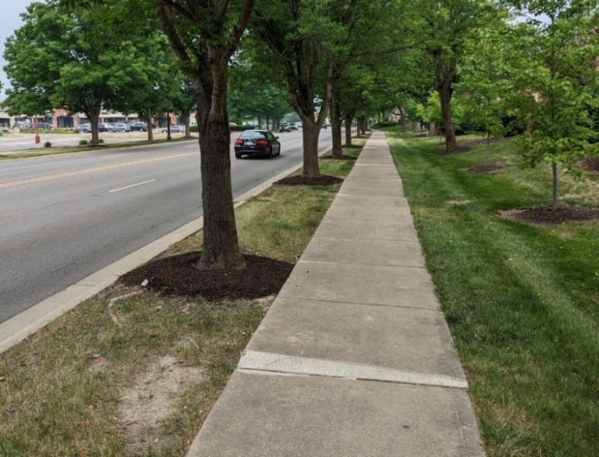
    - Removing trip hazards by shaving the raised sidewalk is highly recommended. See photo 2. University of Wisconsin – Stevens Point research has determined that shaving sidewalks costs approximately $75 per sidewalk square and lasts an average of 8 years.

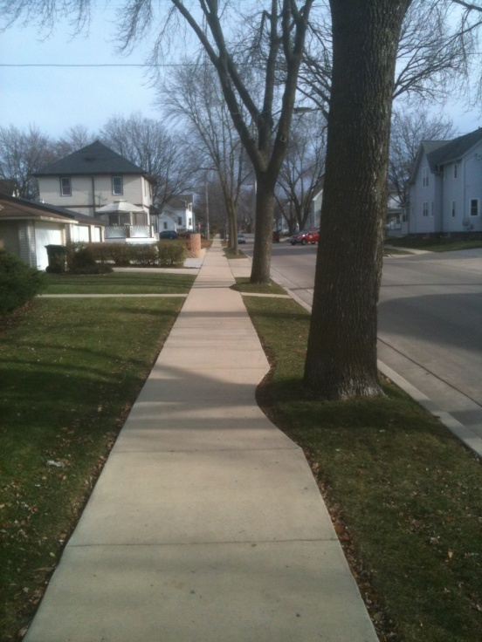

    - Utility Vegetation Management

  - An Annual Tree Permit is required for utility vegetation management. A permit may be waived so long as the City Forester and utility contact maintain good communication regarding work that will impact public trees.

  - Pruning must adhere to standards outlined in the most recent edition of the ISA Best Management Practices for Utility Pruning of Trees as well as ANSI Z133.1 Safety Standards.

